Nitto Gonzalez

Cybersecurity

Active Directory Home lab

Description: In this home Lab I will be deploying two virtual machines with the help of Virtual Box by Oracle. I will then configure one of the virtual machines with Server 2019, this will be my Domain controller. I will then configure my second virtual machine with Windows 10, I will create multiple users using active directory and I will be able to configure them each including their levels of privilege.

Skills/technology: This Home lab will help me develop the following skills

* Active directory
* Virtualization
* DCHP
* IP address configuration
* Privilege control
* Powershell and scripts
* IP leases
* Server 2019
* Virtual Box

Step 1:

I will first need to get the necessary software ready for me to execute my lab. I will download Virtual Box by Oracle, Server 2019 ISO and Windows 10 ISO. After getting all of my necessary software I will configure my virtual machine on Virtual Box, I will allocate 2 GBs of memory to my Domain controller VM along with configuring Server 2019 as the OS.

Step 2:

After the VM is up and running I will configure the network by having two separate connections one to the internet and one which will serve as my internal network and the one that will house my generated users.

After the network is set up I will download Active Directory Domain services onto my Domain Controller and I will create an organizational unit folder in my active directory users and computers tab.

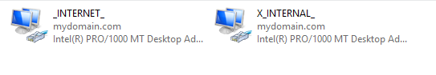

Step 3:

After configuring an Admin user I will then set up Network Address Translation (NAT) so that the second VM is able to communicate with the internet as well as have access to the internal network. This is done by utilizing the remote access feature in Server 2019 and linking it with my internet network connection that I configured in step 2

Step 4:

After configuring NAT onto my Domain Controller VM, I will then configure a DHCP server onto the VM which will create an IP address for every new user connecting to the network. I will configure the IP settings including routing and ip leases, since this is a home lab I will set the lease expiration to 7 days however in a production environment this would have to be configured to whatever best suits the organization.

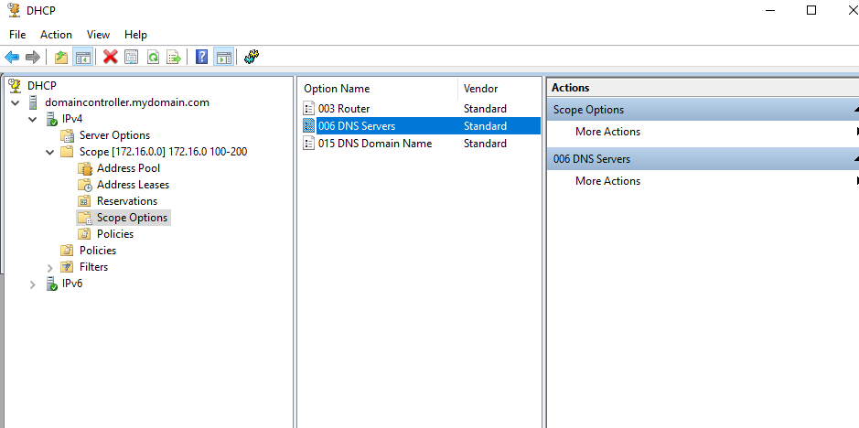

Step 5:

After setting up the DHCP server, I was able to utilize a Powershell script that allowed me to create 1,000 users. This script was very useful as it created the users in less than a minute instead of me manually creating each user and configuring its password settings as that would take a long time.

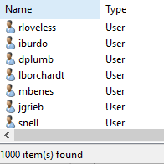

Step 6:

Next we need to set up our other VM with windows 10 installed in it, we need to make sure to select the internal network option in the hypervisor to ensure that it has communication with the Domain Controller VM. We can check that the connection has been established by opening the command line on the Client VM and using the IPconfig command. If everything was done correctly you should see your connection-specific DNS suffix be the name of your Domain.

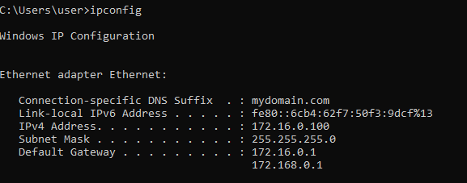

Conclusion:

After configuring both virtual machines I am now able to log into my client VM and access the network through my Domain Controller thanks to the active directory. I am also able to monitor the users from my Domain controller as well as see the leases on their IPs that they dynamically assigned with DCHP.